Microservices

Microservices are small services that can be independently developed, built and deployed.

Spring provides a module called spring microservices which allows you to develop microservices.

Pre-requisites

* Java
* Spring Boot
* Spring REST
* Spring Initializr project

Simple Spring REST project with Spring Boot

@SpringBootApplication

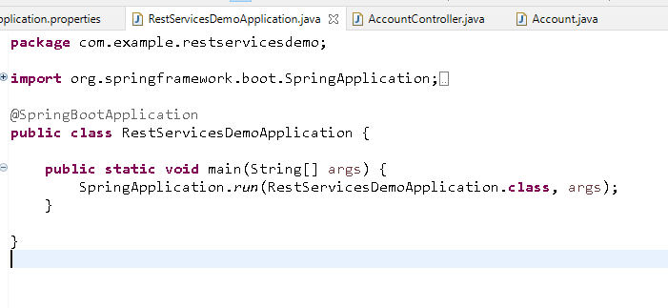

Account.java

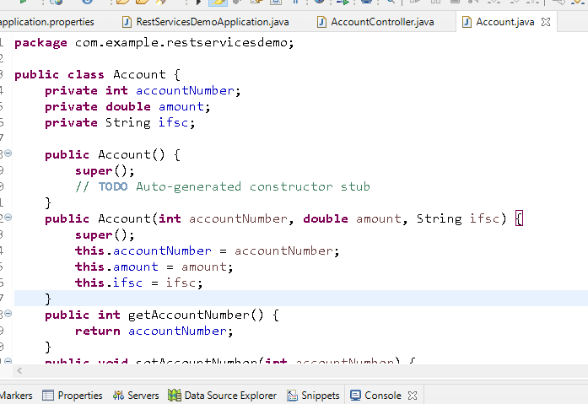

AccountController.java

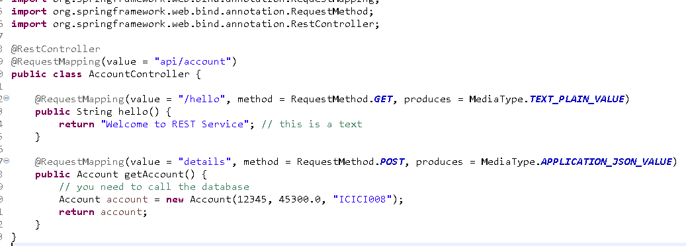

Output:

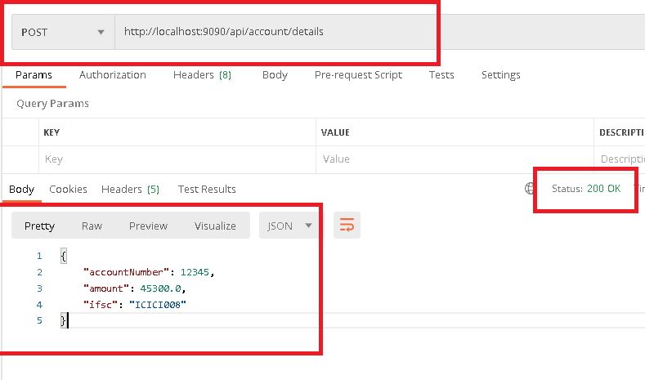

Client can send input via a text box in mobile or web or from credit card machine and so on, you must know how to extract those inputs in the rest service

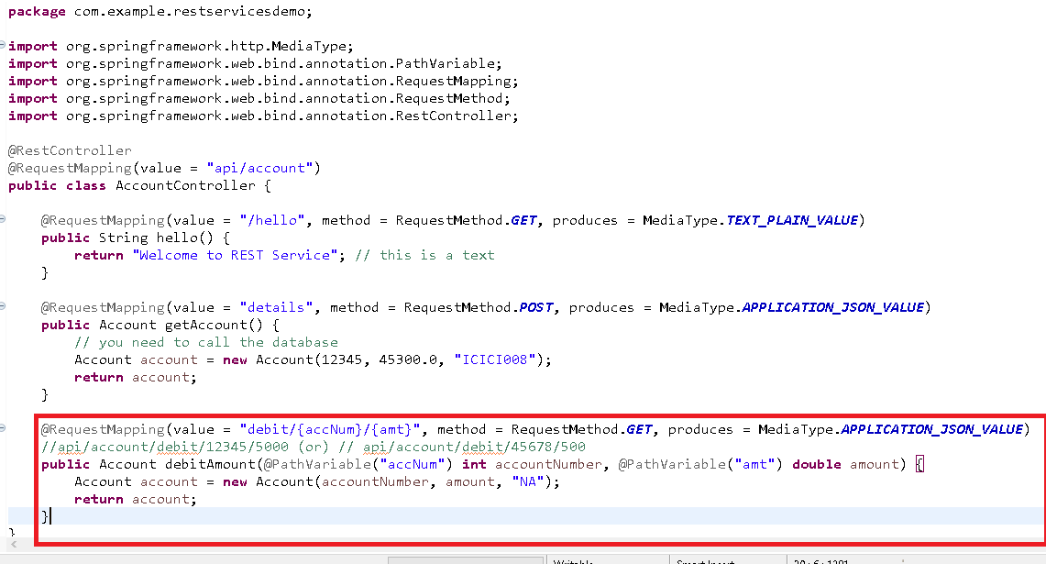

Output

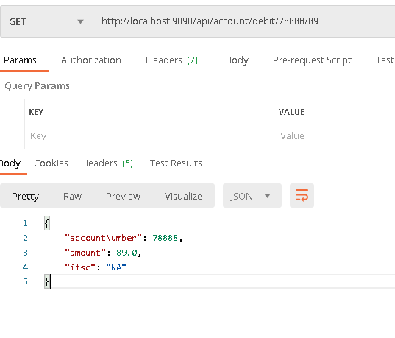

Monolithic vs Microservice architecture

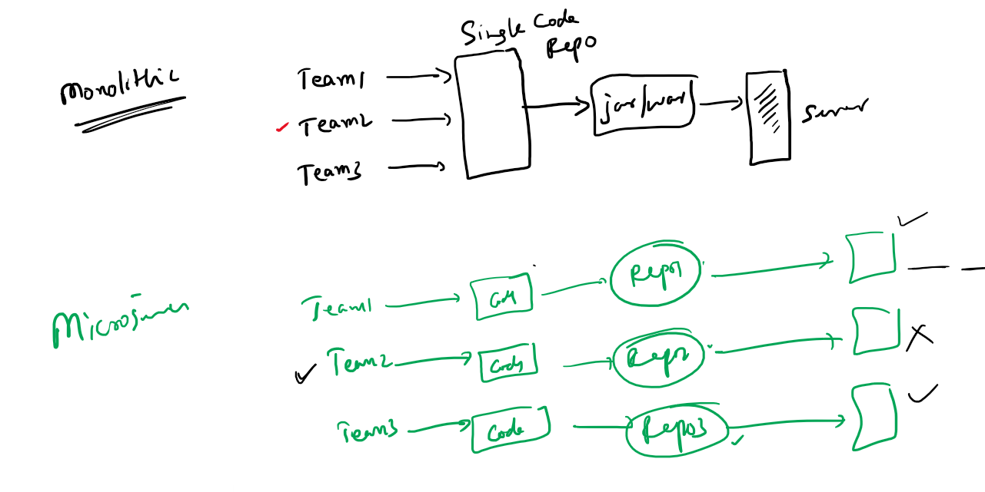

Spring Framework integrated with Netflix OSS to make microservices developed through spring

Spring Framework released a module called *Spring Cloud* which is dependent on *Spring Boot*

Using these two projects you can quickly develop microservices with simple annotations.

Steps involved in microservices

1. Service Discovery: where all the microservice registers to this registry so that microservices can locate other microservices
2. Discovery Clients: These are microservices that are called as clients which registers with the Service Discovery
3. Configuration Server:
4. Circuit Breaker:
5. API Gateway:

Service Discovery: It is implemented by Netflix and in spring you will use Eureka Server for Service discovery

Discovery Clients: It is implemented by Netflix and in spring you will use Eureka clients to register with Eureka server

Creating Service Discovery

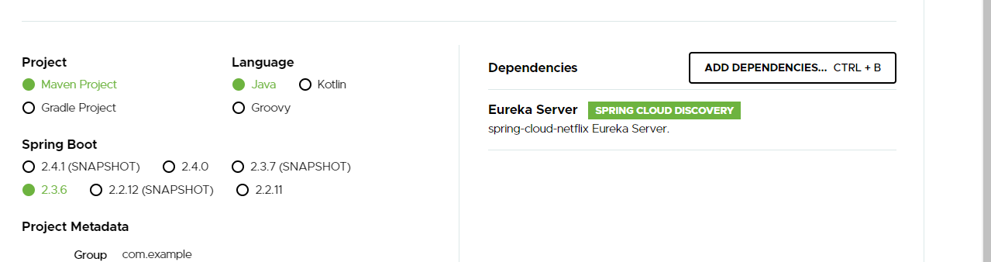

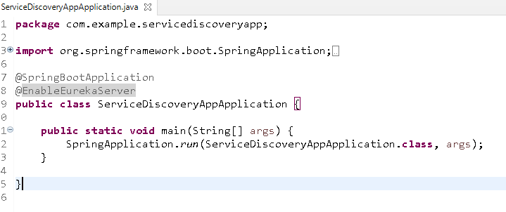

@EnableEurekaServer: creates a service discovery where all the @EnableEurekaClient would be registered.

Service Discovery acts like a client as well so you must disable few properties in the application.yml file

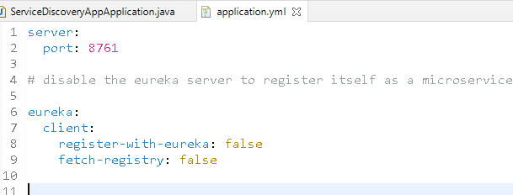

server.port: 8761, this is the default port all your microservice will register with the service discovery

eureka.client.register-with-eureka: false, this disables service discovery to register itself in its registry

eureka.client.fetch-registry: false, this disables client to fetch informations from service discovery

Output:

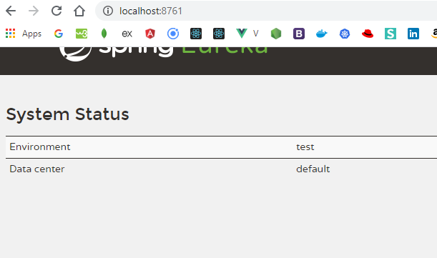

This dashboard shows all the registered microservices

Creating a microservice

1. Web
2. Eureka Client
3. Devtools (optional)
4. Actuator (optional)

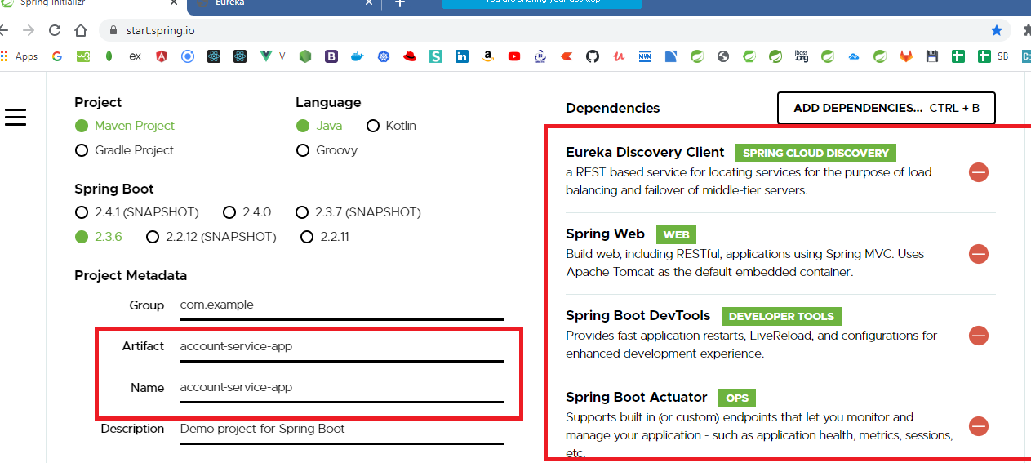

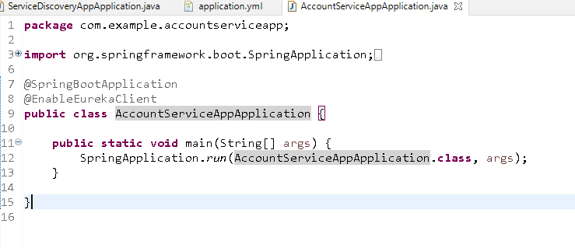

Now this is a microservice that tries to register with Service Discovery running in 8761 port

However every microservice needs a logical name that helps other microservices to communicate

bootstrap.yml

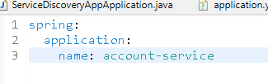

This is the file that is loaded before application.yml, you keep some configurations that should be loaded before application.yml, like application names, profiles, configuration servers url and so on

application.yml

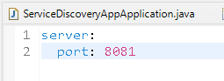

Output:

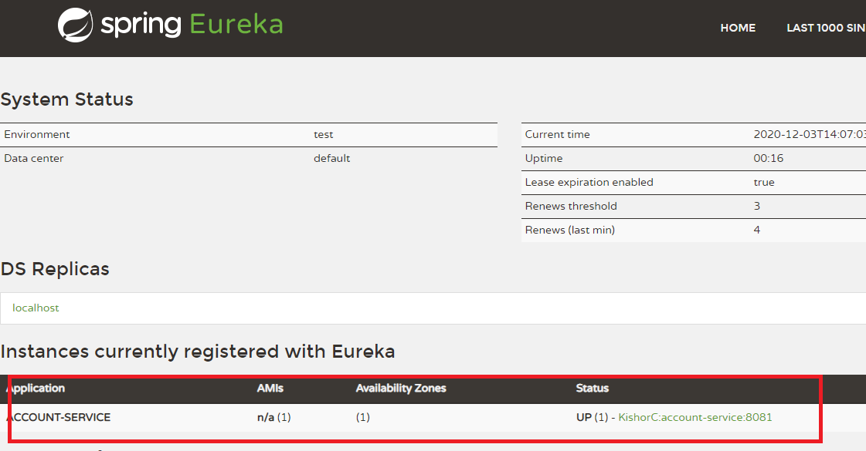

Eureka has only one instance of Account-Service if you need to multiple instances of account service then you need to launch this service in another port other than 8081, because the instances created in local machine.

You can use below commands from your project location

mvn package

java -jar target/file-name.jar --server.port = 8082

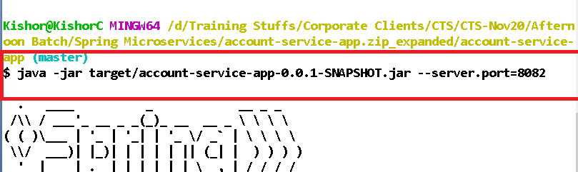

This will show up in the eureka dashboar, we are running one instance in eclipse & other in command prompt of account service

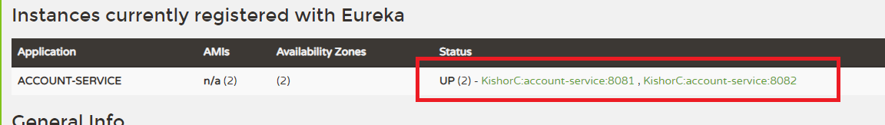

Exercise:

Create another microservice named paytm service and register with eureka with a different application name

Store this exercise in cts-hands-on repository in afternoon folder with another folder named microservice

Account.java

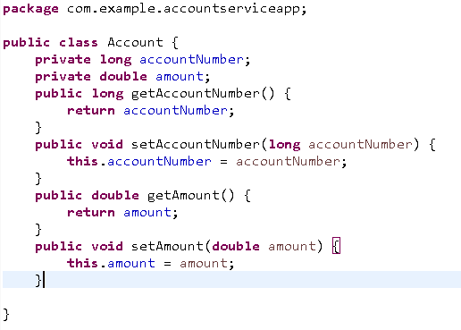

AccountService.java

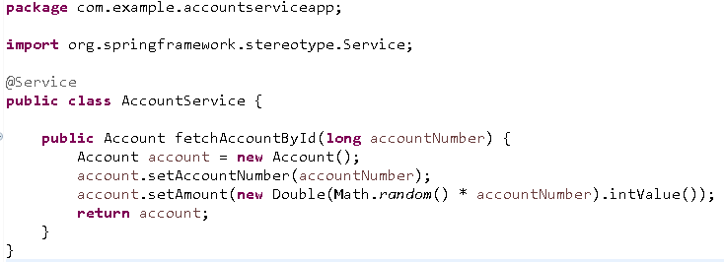

AccountRest.java

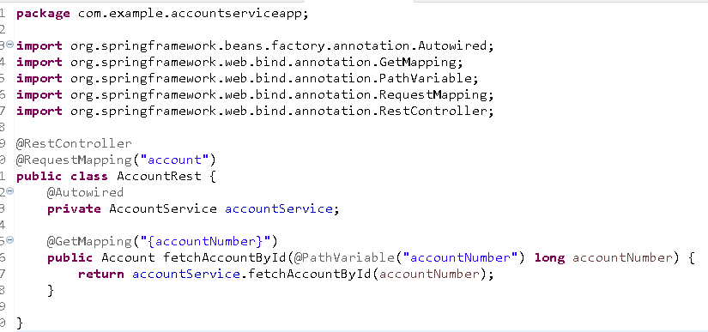

Here the REST endpoint to access account service is <http://localhost:8081/account>, however the microservice which has to communicate will not have idea about the other microservice location, so they will use the logical name of the microservice registered in the service-discovery, i.e., **ACCOUNT-SERVICE**

Communication between the microservices

When any microservice has to communicate with other microservices they have to use

* service-id or logical name registered with service-discovery
* instance that can make REST calls, for ex: In Spring you have RestTemplate

Wallet Service communicates with Account Service

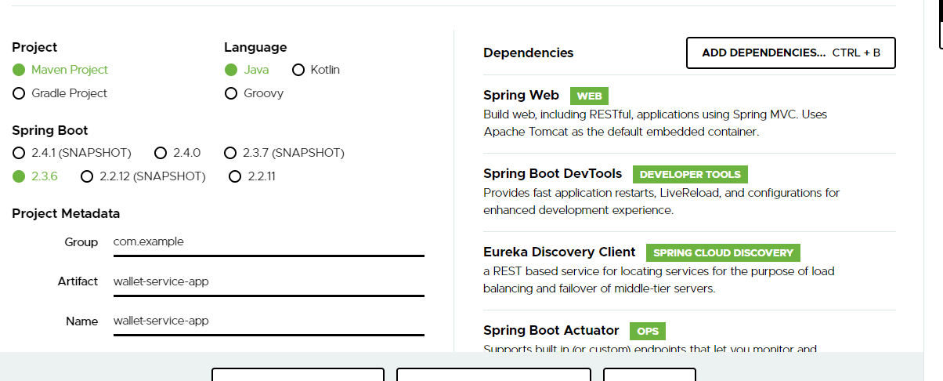

Add Eureka Client annotation

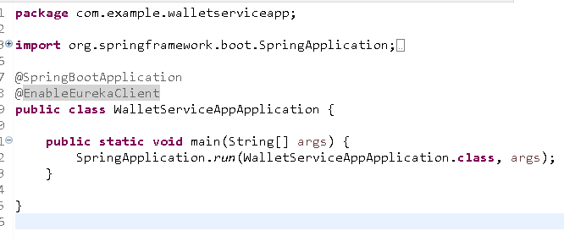

application.yml

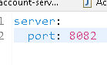

bootstrap.yml

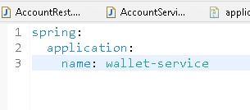

Creating RestTemplate instance with LoadBalanced

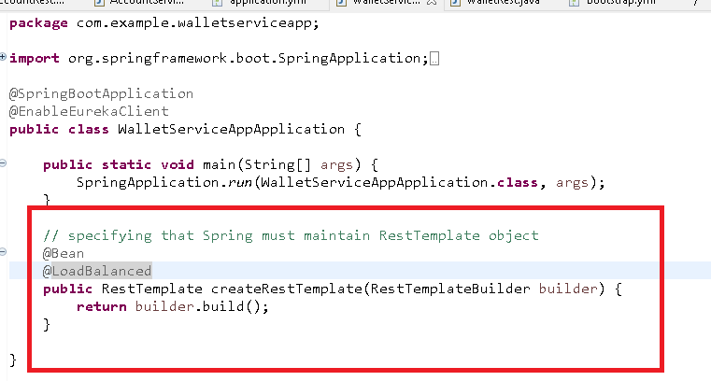

@LoadBalanced creates the load balanced backed RestTemplate object

AccountStructure.java: This must match to json structure

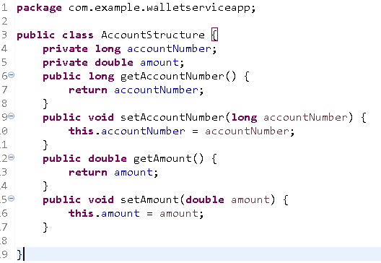

Wallet.java

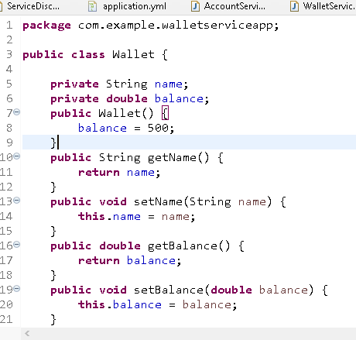

WalletService.java

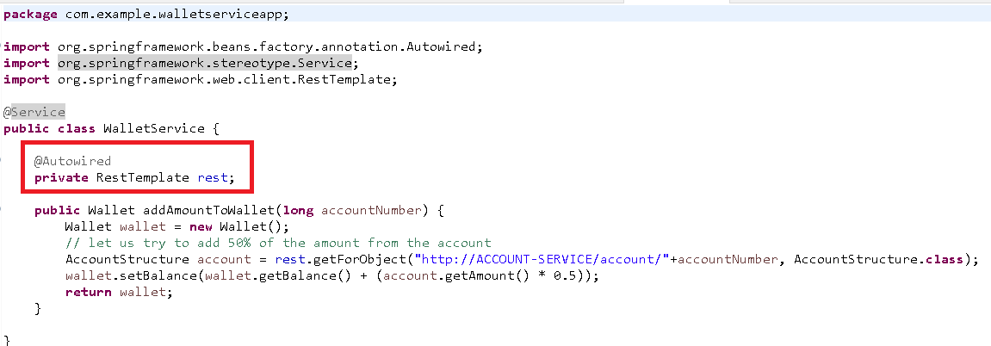

WalletRest.java

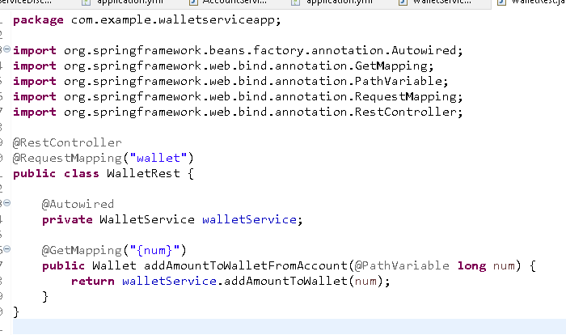

Output:

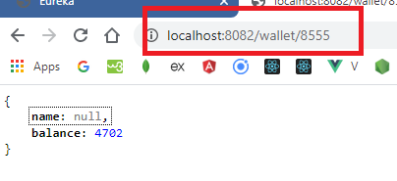

Note: name is null because we didn’t initialize it in wallet object, <http://localhost:8082/wallet/8555>

Sends request to

<http://account-service/account/8555>